**ESTIMATION AND PREDICTION OF**

**HOSPITALIZATION AND MEDICAL CARE COSTS**

SPECIFY THE BUSINESS PROBLEM :- ->Medical costs are one of the most common recurring expenses in a person's life. Based on different research studies, BMI, ageing, smoking, and other factors are all related to greater personal medical care costs. The estimates of the expenditures of health care related to obesity are needed to help create cost-effective obesity prevention strategies. Obesity prevention at Young age is a top concern in global health, clinical practice, and public health.

LITERATURE SURVEY:-

-> The prevalence of obesity, which is defined as a body mass index (BMI) greater than 30, has increased dramatically in the United States since the late 1990s. So much so that recently obesity has been officially recognized as a disease by the American Medical Association, an action that could put more emphasis on the health condition by doctors and insurance companies to minimize its adverse effects. Currently, rates of obesity exceed 30% in most sex and adult age groups, whereas its prevalence among children and adolescents, defined as a BMI of more than the 95th percentile, has reached 17%.

The alarming rates of the high prevalence of obesity have posed a significant public health concern as well as a substantial financial burden on our society because obesity is known to be a risk factor for many chronic diseases, such as type 2 diabetes, cancer, hypertension, asthma, myocardial infarction, stroke, and other conditions. To understand the economic burden of obesity, several studies have attempted to estimate the attributable costs of obesity, following the burden-of-illness literature on other disease areas. A previous cost-of-illness study estimated that healthcare spending attributable to the rising prevalence of obesity has increased by 27% between 1987 and 2001

Data visualizations:-

1. Average age of male and female

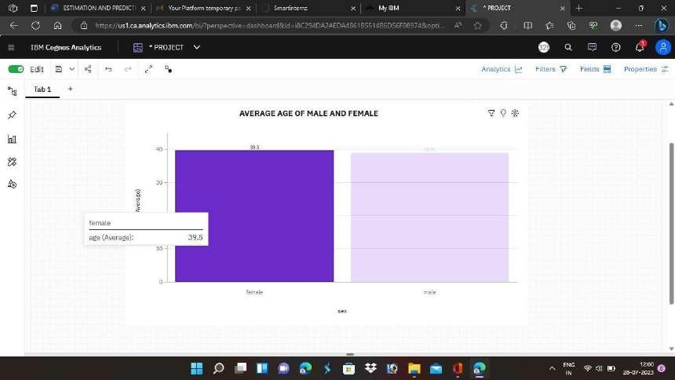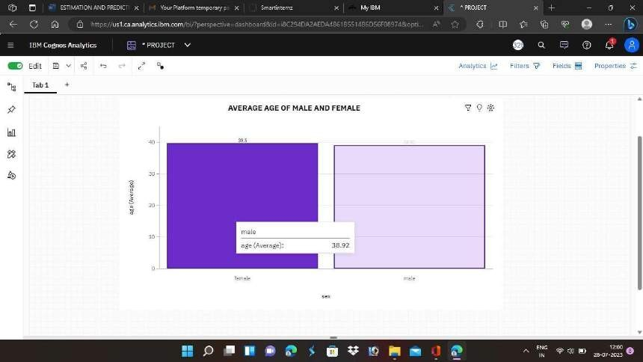

1. BMI of a person by Age :-

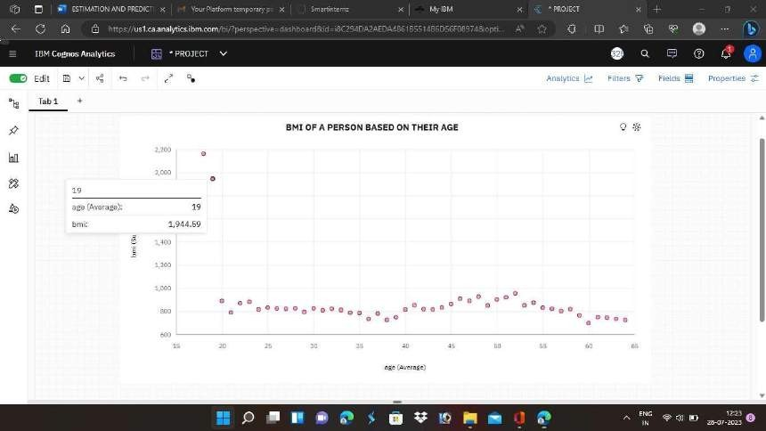

1. NUMBER OF CHILDERN BY AGE AND SMOKER:-

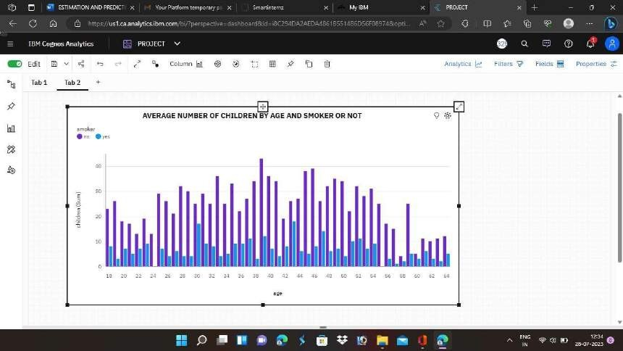

1. THE AVERAGE AGE OF PEOPLE ACCORDING TO

THEIR REGION AND GENDER :-

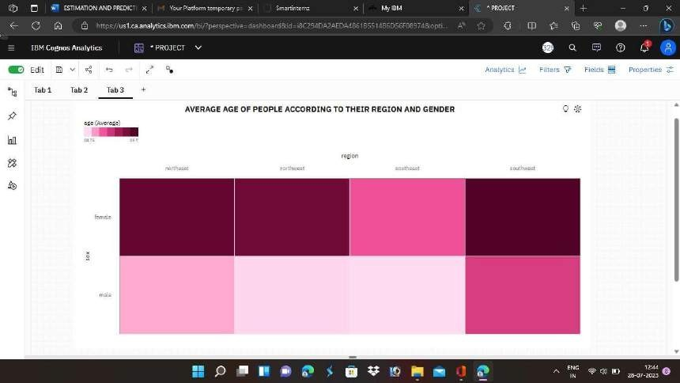

1. CHARGES PAID BY PEOPLE ACCORDING TO THIER GENDER ,REGION AND SMOKER :-

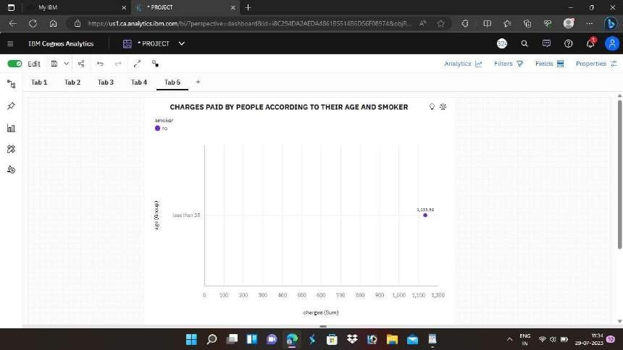

1. BMI OF PERSON BY THEIR GENDER AND SMOKER:-

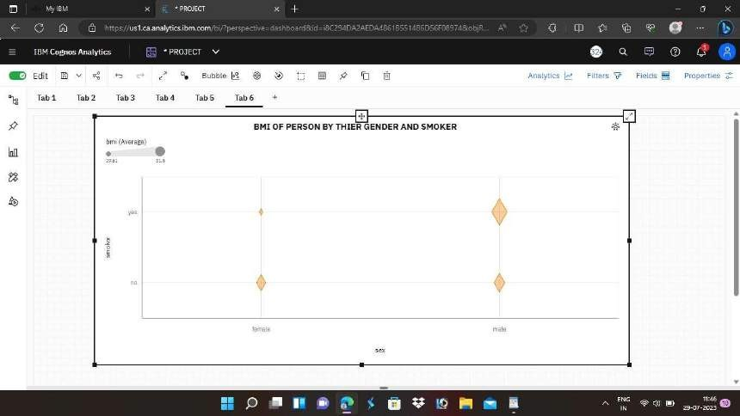

1. CHARGES PAID BY PEOPLE ACCORDING TO THEIR

GENDER,REGION AND SMOKER :-

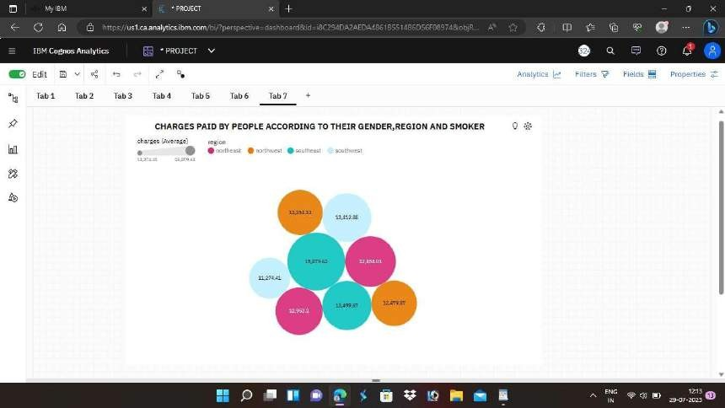

1. AVERAGE BMI OF PEOPLE BY GENDER AND REGION:-

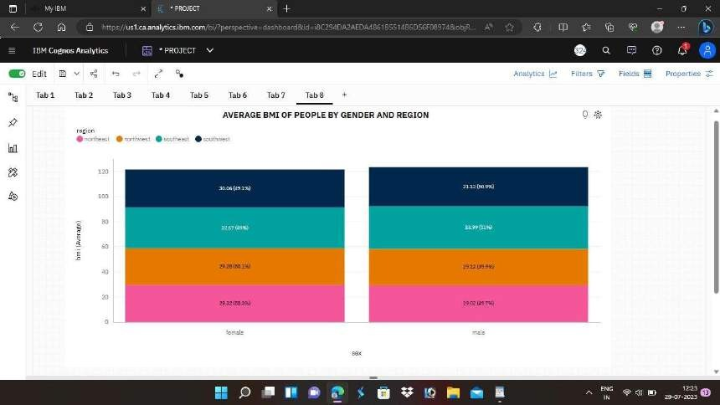

1. TOP 100 CHARGERS PAID BY PEOPLE BASED ON BMI AND COLOURED BY REGION :-

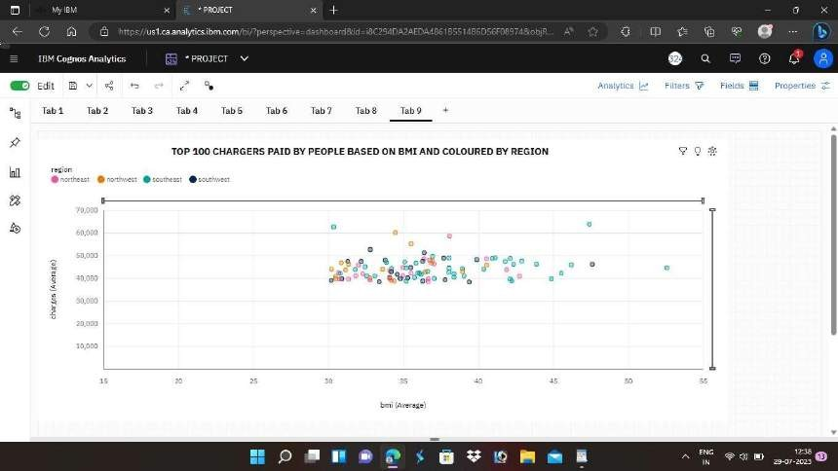

1. NUMBER OF CHILDERN TO THE PEOPLE BY REGION:-

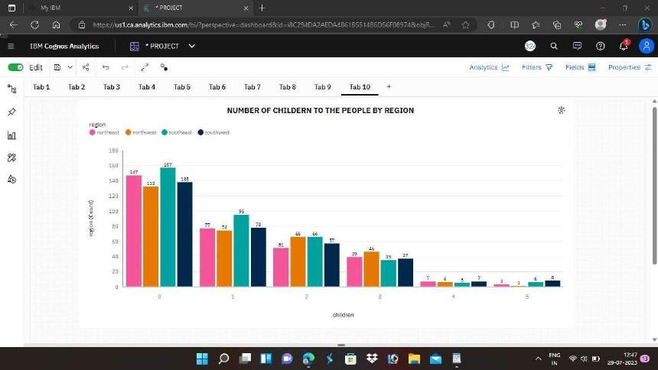

1. CHAGES PAID BY THE PEOPLE BY REGION:-

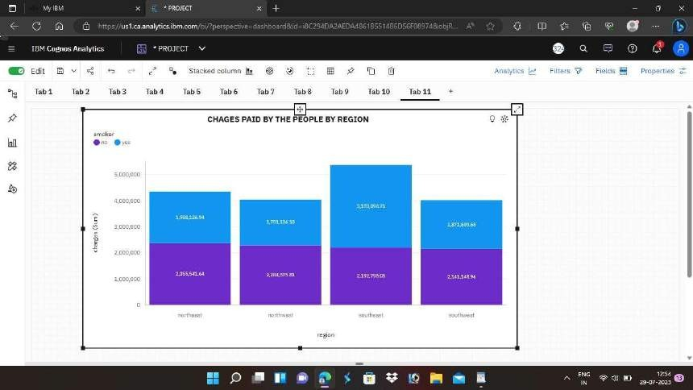

1. CHARGES BASED ON THE NUMBER OF CHILDERN:-

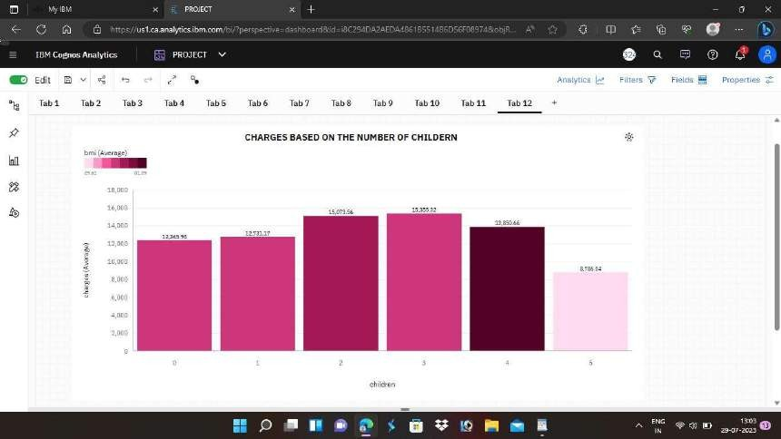

# DASHBOARDS:-

DASHBOARDS LINK :-

https://us1.ca.analytics.ibm.com/bi/? perspective=dashboard&pathRef=.my_folders% 2FPROJECT&action=view&mode=dashboard

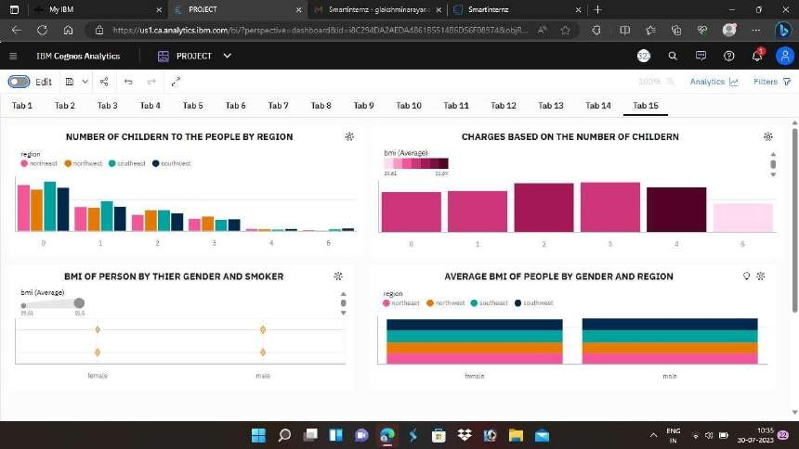

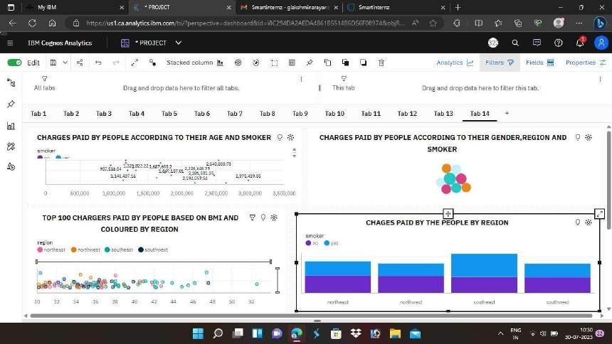

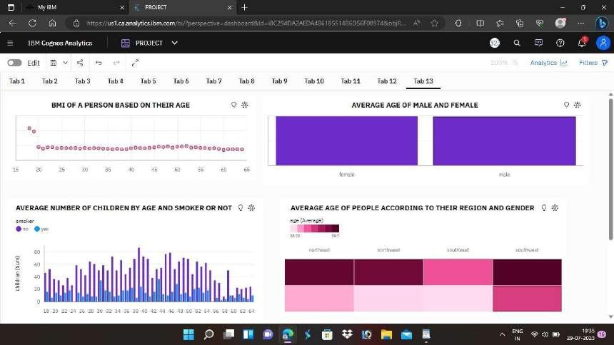

**STORY**:-

STORY LINK:- https://us1.ca.analytics.ibm.com/bi/? perspective=story&pathRef=.my_folders% 2FMEDICAL%2BCOST%2BCARE%

2BSTORY&action=view&mode=dashboard



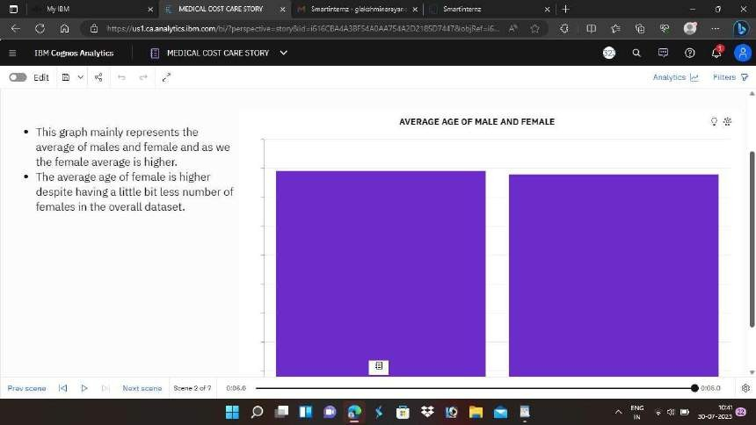

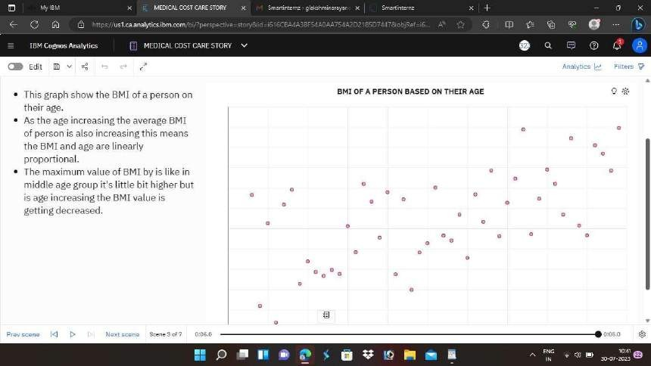

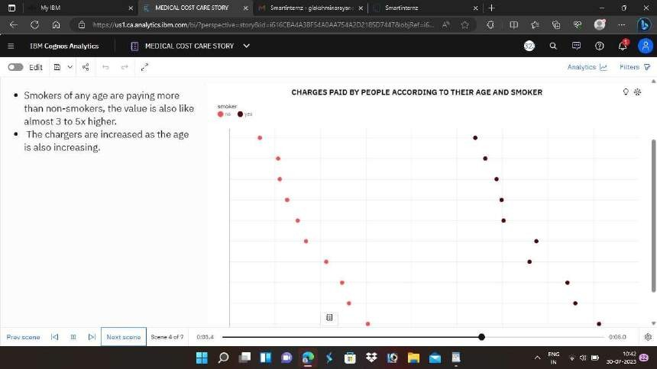

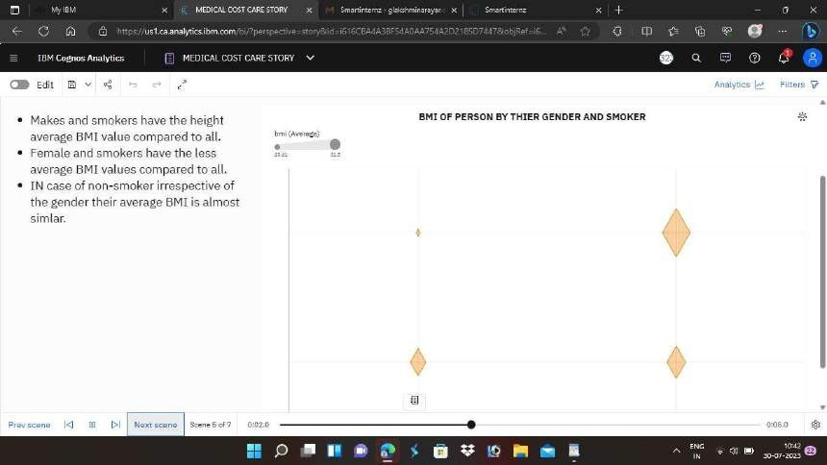

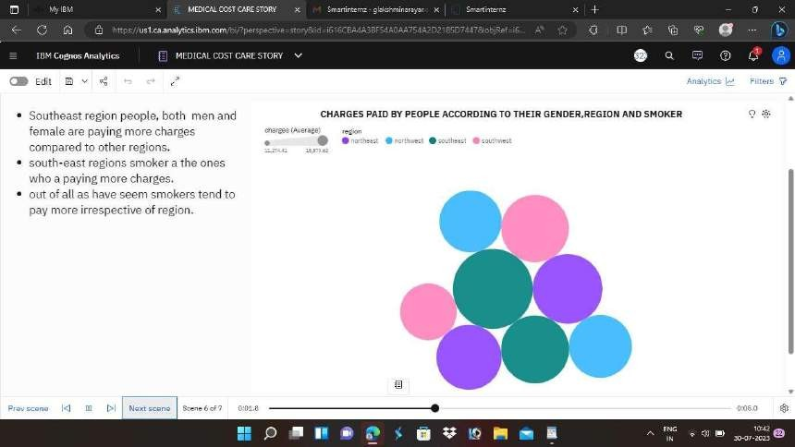



# REPORT:-

REPORT LINK:- https://us1.ca.analytics.ibm.com/bi/? pathRef=.my_folders%2Fproject%2Breport

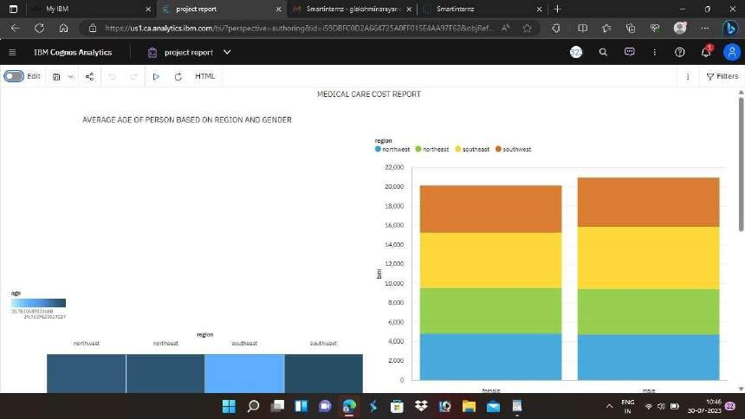

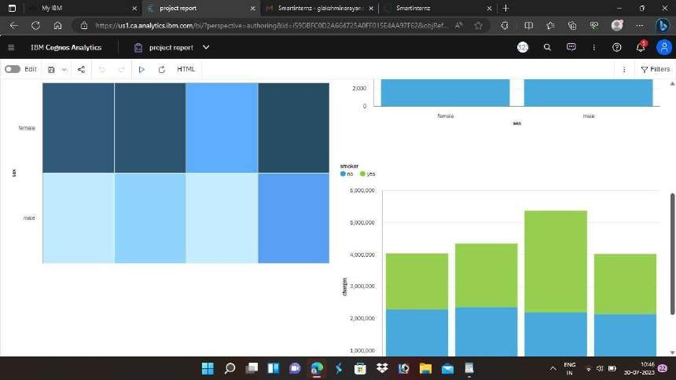

# WEB INTEGRATION :-

